SEMESTER 1
ELECTRONICS FOUNDATIONS: CIRCUITS, SENSORS AND THE PATH TO EDGE AI


Module Overview
This module builds a complete, practical foundation in electronics for learners with no prior experience — starting with voltage, current and resistors, moving through capacitors, transistors, relays and digital logic, and finishing with analog-to-digital conversion and real sensors. Every concept is explained from first principles with a real-world analogy, a worked example, common beginner mistakes and a quick self-check, so learners can always predict what a circuit should do before it is built.
All sections feed one larger project: the SenseNode, a low-cost smart sensing node that reads light, temperature and soil moisture, switches a fan or pump through a transistor-driven relay, logs data, and recognises unusual conditions with a simple on-device pattern-recognition model. The sections are organised as self-contained topics rather than fixed time slots, so pace can flex per batch.
# | Topic | Key Concepts
1 | Introduction to Electronics, Tools & Safety | Sense–decide–act, schematics, LED resistor
2 | Voltage, Current, Resistors & the Voltage Divider | Ohm's law, power, voltage divider
3 | Capacitors & Analog Electronics | Time constant, RC filters, debouncing
4 | Transistors & Relays | BJT/MOSFET switching, relays, flyback diode
5 | Digital Electronics | Binary, logic gates, pull-ups, hysteresis
6 | ADC & Sensors as Analog Devices | Resolution, sensor dividers, calibration, pixels
7 | Debugging & System Integration | Debugging method, datasheets
8 | Capstone: The SenseNode | System design, pattern recognition, documentation

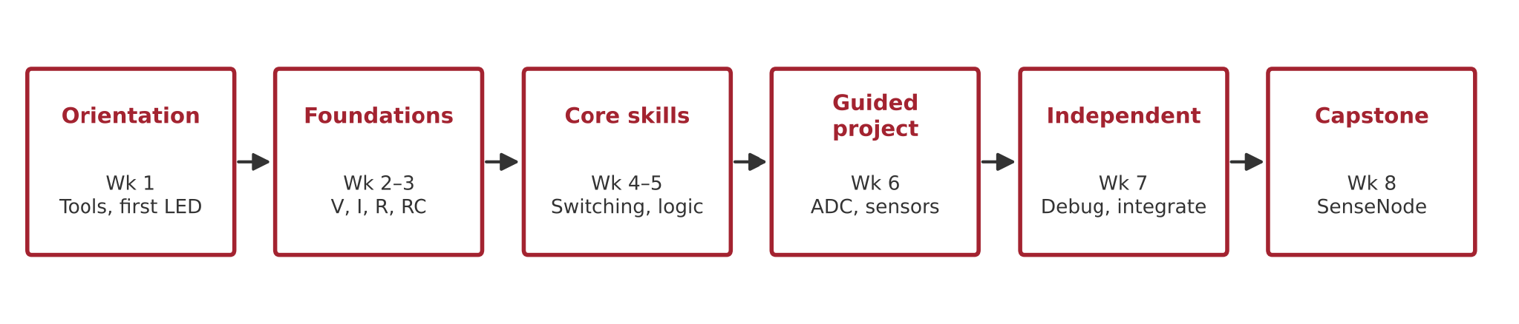
Figure 0.1: Course roadmap — six phases from orientation to a portfolio-ready capstone, one SenseNode subsystem added each week.

Learning Outcomes
By the end of this module, the learner will be able to:
# | Outcome
LO1 | Explain voltage, current, resistance and power, and calculate them with Ohm's law to within 5% of a measured value
LO2 | Design a voltage divider for a target output and select standard resistor values and power ratings
LO3 | Implement an RC circuit for timing, smoothing and button debouncing
LO4 | Distinguish analog from digital signals and implement logic functions with gates and GPIO
LO5 | Build a transistor switch that drives a relay safely, with base-resistor sizing and a flyback diode
LO6 | Configure a microcontroller ADC and convert raw counts to volts and physical units
LO7 | Interface and calibrate analog sensors by modelling each as a voltage divider
LO8 | Diagnose circuit faults with a multimeter and a structured debugging method
LO9 | Implement sensor data logging and simple pattern recognition, and explain how ADCs create camera pixels for computer vision and edge AI
LO10 | Document and present a hardware project professionally

1. Introduction to Electronics, Tools & Safety
Why this matters: Electronics turns physical events (light, heat, movement) into information, and information into action. Phones, cars, medical devices, factory robots and smart cameras all follow the same pattern. Without this big picture, later topics become a disconnected list of parts. In the capstone, this is where the SenseNode project brief, GitHub repository and engineering notebook are created.

1.1 What Is Electronics?
Electronics is the control of electric charge to sense, decide and act. A sensor turns a physical quantity into a voltage; a converter (the ADC) turns that voltage into a number; a controller such as a microcontroller decides what to do; and an actuator (LED, fan, relay, motor) carries out the action. Analog electronics handles smooth, continuously varying signals; digital electronics handles the two states 0 and 1.
A useful analogy is the human body: the eyes are sensors, the nerves are wires, the brain is the controller, and the muscles are actuators. An automatic street light follows the same chain — a light sensor detects darkness, a controller decides it is night, and a switch turns the lamp on.
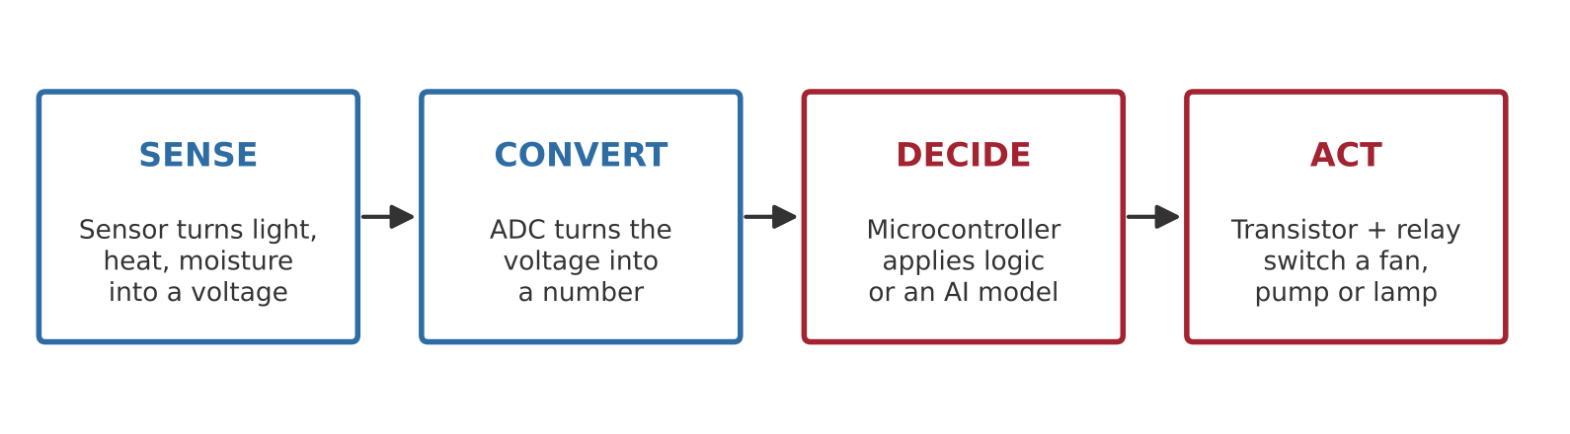
Figure 1.1: The sense → convert → decide → act chain used by every system in this module, from the SenseNode to an edge-AI camera.

1.2 Tools and Safety
- Breadboard — a solderless board whose short rows are connected internally; components placed in the same row are electrically joined. The centre gap separates the two halves.
- Digital multimeter — measures voltage across a component (probes in parallel) and current through a path (meter in series). Measuring current in parallel can blow the meter fuse.
- Simulator first — every circuit is first tested in Wokwi or Falstad, so mistakes cost nothing.
- Common ground — every part of a circuit, and every power supply that works together, must share one ground reference.
- Low voltage only — stay within 5–12 V DC; never connect hobby relay modules to mains power.

1.3 Reading a Schematic
A schematic shows connections, not physical layout — like a metro map rather than a street map. These six symbols cover almost every circuit in this module:
Symbol | Component | What It Does
Circle with + / − | Voltage source / battery | Provides the electrical 'push' (volts)
Zig-zag line | Resistor | Limits current; converts current to voltage
Two parallel plates | Capacitor | Stores charge; smooths and times signals
Triangle with bar and arrows | LED (diode) | Lets current flow one way and emits light
Circle with three leads | Transistor | Electronically controlled switch
Stacked horizontal lines | Ground | 0 V reference shared by the whole circuit

1.4 Your First Circuit: LED + Resistor
An LED drops a roughly fixed forward voltage (about 2 V for a red LED) and must have its current limited by a resistor, otherwise it burns out. The resistor value comes from R = (Vsupply − VLED) / I.
Worked example: 5 V supply, red LED, target 10 mA → R = (5 − 2) / 0.010 = 300 Ω → choose the next standard value, 330 Ω. On a 3.3 V ESP32 pin at about 8 mA: (3.3 − 2) / 0.008 ≈ 160 Ω → 150 Ω.
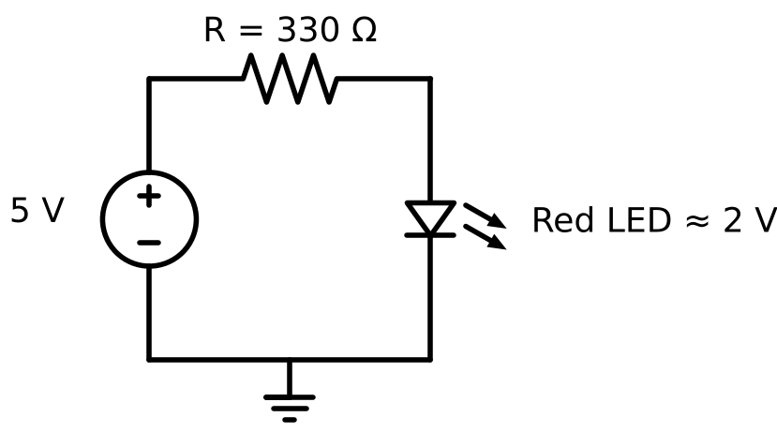
Figure 1.2: Current-limited LED circuit — the resistor acts like a tap that protects the LED.
Common Mistakes
- LED inserted backwards — the long leg (anode) goes to the positive side.
- No series resistor — the LED and the microcontroller pin can be damaged.
- Using 5 V in the calculation when the board pin is actually 3.3 V.
Quick Check
- To measure current, is the meter placed in series or in parallel? (Series)
- In an automatic hand dryer, which part is the sensor? (The infrared proximity sensor)
- If the supply rises from 5 V to 9 V with the same resistor, what happens to the LED current? (It more than doubles)

2. Voltage, Current, Resistors & the Voltage Divider
Why this matters: Every circuit and every sensor in this module rests on Ohm's law and the voltage divider. They let you predict a circuit before building it, and bring any voltage into the safe range of a chip. Skipping them leads to burnt parts and misread sensors. In the capstone, the divider is the input stage for every sensor and for battery monitoring.

2.1 Voltage and Current
Voltage (V, volts) is the electrical push between two points — it is always measured between two points. Current (I, amperes) is the amount of charge flowing per second through a path, and it only flows in a closed loop. Two simple rules (Kirchhoff's laws) follow: the voltages around a loop add up to the supply, and the current entering a junction equals the current leaving it.
Analogy: think of a water tank. The height of the water is the voltage, the flow through the pipe is the current, and a closed pipe loop is needed for water to keep flowing.

2.2 Resistors: Ohm's Law, Power, Series and Parallel
Ohm's law: V = I × R. Power: P = V × I = I² × R. Most through-hole resistors are rated 1/4 W (250 mW); exceeding this makes them hot and eventually fail. Resistors come in standard E12/E24 values with a tolerance of ±5% or ±1%, and coloured bands encode the value.
Combination | Formula | Example
Series | R = R1 + R2 | 1 kΩ + 2.2 kΩ = 3.2 kΩ
Parallel | 1/R = 1/R1 + 1/R2 | 10 kΩ ∥ 10 kΩ = 5 kΩ
Power | P = V² / R | 220 Ω across 5 V = 114 mW (safe for 1/4 W)
Current | I = V / R | 1 kΩ across 5 V = 5 mA

2.3 The Voltage Divider
Two resistors in series split a voltage. The output is taken across the bottom resistor: Vout = Vin × R2 / (R1 + R2). Any load connected to Vout draws current and pulls it down (called loading), so the load's resistance should be at least 10 times larger than R2.
Worked example: an ESP32 ADC input must stay below 3.3 V, but the signal goes up to 12 V. Choose R1 = 27 kΩ and R2 = 10 kΩ → Vout = 12 × 10 / 37 = 3.24 V. Safe.
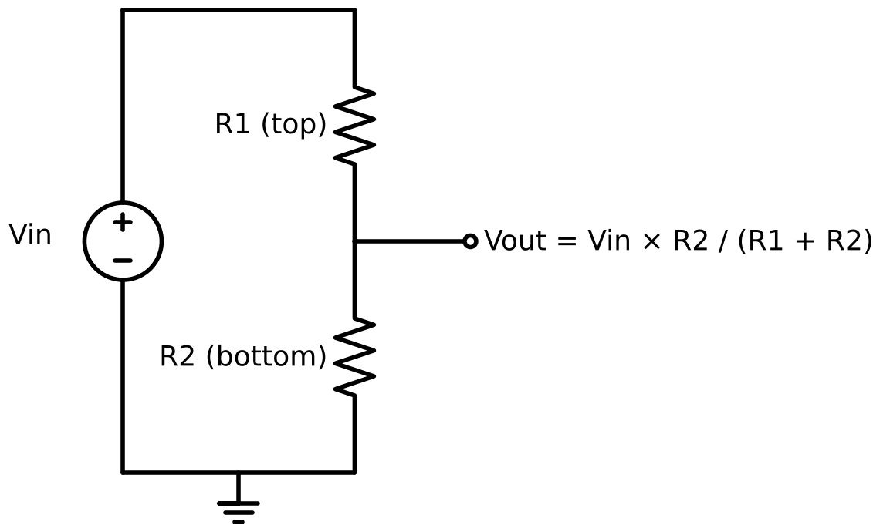
Figure 2.1: Voltage divider — the same two-resistor circuit sits behind almost every analog sensor.
Common Mistakes
- Saying 'voltage through' a component — voltage is across, current is through.
- Measuring resistance in a powered circuit.
- Swapping R1 and R2 in the divider.
- Using very small values (100 Ω) that waste current, or very large values (10 MΩ) that the ADC input loads down.
Quick Check
- Two resistors in series on 5 V; one drops 3.2 V. What does the other drop? (1.8 V)
- Two 10 kΩ resistors in parallel equal? (5 kΩ)
- R1 = R2 and Vin = 5 V. What is Vout? (2.5 V)

3. Capacitors & Analog Electronics
Why this matters: Real signals are noisy and change over time. Capacitors store charge and resist sudden voltage changes, so they smooth power supplies, filter sensor signals, create delays and stop buttons from 'bouncing'. Without them, sensor readings jitter and buttons register several presses. In the capstone, an RC filter cleans each sensor input and debounces the mode button.

3.1 Analog Signals and Noise
An analog signal can take any value in a range — a thermistor might output 1.62 V at one temperature and 1.63 V at another. A digital signal has only two meaningful states. Noise is unwanted variation caused by power supplies, long wires, nearby motors and the environment. The key question is always: how big is the change you care about compared with the random wobble? A useful analogy: a dimmer is analog, a light switch is digital, and noise is the static on a radio.

3.2 Capacitors and the RC Time Constant
A capacitor (measured in farads; usually µF or nF) stores charge. When it charges through a resistor, it reaches 63% of the supply after one time constant τ = R × C, and is effectively full after 5τ. With 10 kΩ and 100 µF, τ = 1 s. Electrolytic capacitors are polarised (they have + and − legs); ceramic capacitors are not. The analogy is filling a bucket through a narrow hose — fast at first, then slower as it fills.
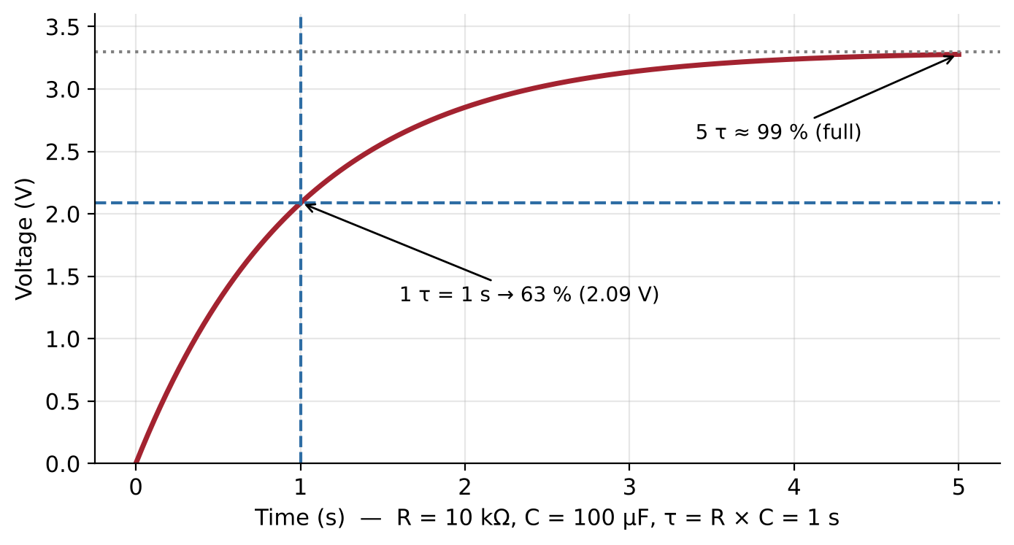
Figure 3.1: RC charging curve — 63% after one time constant, about 99% after five.

3.3 RC Filters and Debouncing
A series resistor with a capacitor to ground forms a low-pass filter, with cutoff frequency fc = 1 / (2πRC). With 10 kΩ and 1 µF, fc ≈ 16 Hz: slow sensor changes pass through, fast noise is reduced. Mechanical buttons 'bounce' for a few milliseconds, so one press can register as several; a 10 kΩ + 1 µF network (≈ 10 ms) or a short software delay fixes it. Every chip should also have a 100 nF bypass capacitor across its power pins. The same idea can be done in software with a moving average.
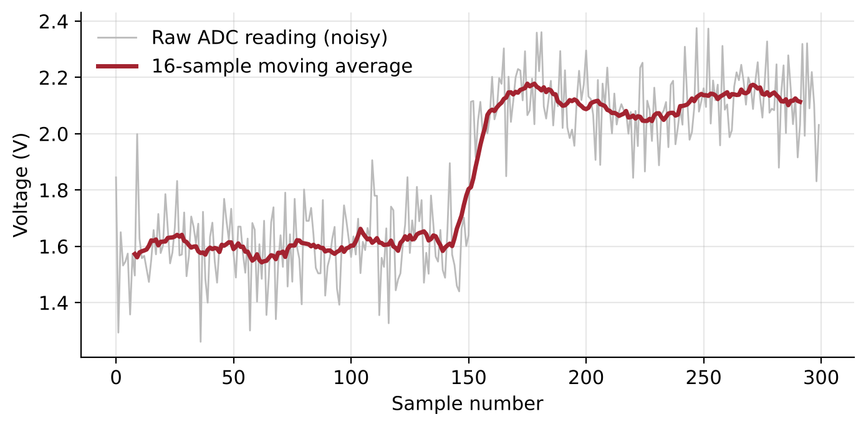
Figure 3.2: A 16-sample moving average removes most of the random noise while still following the real step change (illustrative data).
Common Mistakes
- Inserting an electrolytic capacitor backwards.
- Confusing µF and nF (a factor of 1000).
- Expecting the capacitor to be full after one time constant.
- Filtering so heavily that the signal lags behind real changes.
Quick Check
- Is a thermistor's output analog or digital? (Analog)
- After 5τ, roughly what percentage charged? (About 99%)
- Doubling C does what to the cutoff frequency? (Halves it)

4. Transistors & Relays
Why this matters: A microcontroller pin can supply only about 20 mA, but a fan, pump or lamp needs far more. A transistor is an electronically controlled switch, and a relay is a mechanical switch moved by an electromagnet; together they let a tiny 3.3 V signal control a much larger load. Driving a motor directly from a GPIO pin damages the board. In the capstone, the SenseNode switches its fan through a transistor-driven relay.

4.1 The Transistor as a Switch
In an NPN BJT, a small base current allows a much larger collector current to flow. For a reliable 'fully on' switch, design with a forced gain of 10 (base current = load current / 10). A MOSFET is controlled by gate voltage rather than current; choose a 'logic-level' part whose datasheet gives a low Rds(on) at your gate voltage, and add a 100–220 Ω gate resistor and a 10 kΩ pull-down.
Worked example: a 70 mA relay coil driven from a 3.3 V pin → Ib = 7 mA → Rb = (3.3 − 0.7) / 0.007 ≈ 371 Ω → choose 330 Ω.
Feature | BJT (e.g. 2N2222) | MOSFET (e.g. IRLZ44N)
Controlled by | Base current | Gate voltage
Needs | Base resistor | Gate resistor + pull-down
On-state loss | Vce(sat) ≈ 0.2–0.3 V | Very low Rds(on)
Best for | Small loads, relays, LEDs | Larger currents, motors, PWM

4.2 Relays and Isolation
Energising the relay coil pulls a contact from NC (normally closed) to NO (normally open), with COM as the common terminal. The coil and the contacts are electrically separate, so the load circuit is isolated from the control electronics. Relays are slow (milliseconds) and wear out over time; MOSFETs and solid-state relays are alternatives for frequent switching.
Terminal | Unpowered Coil | Powered Coil
COM–NC | Connected | Open
COM–NO | Open | Connected

4.3 Driving Loads Safely: Flyback Diodes and Power Budgets
When a coil switches off, its collapsing magnetic field produces a large reverse voltage spike that can destroy the transistor or reset the microcontroller. A flyback diode (1N4007) placed across the coil — cathode (striped end) to +V — gives that energy a safe path. Finally, add up every load in a power budget and compare it with what the supply can deliver (a USB 2.0 port typically supplies 500 mA).
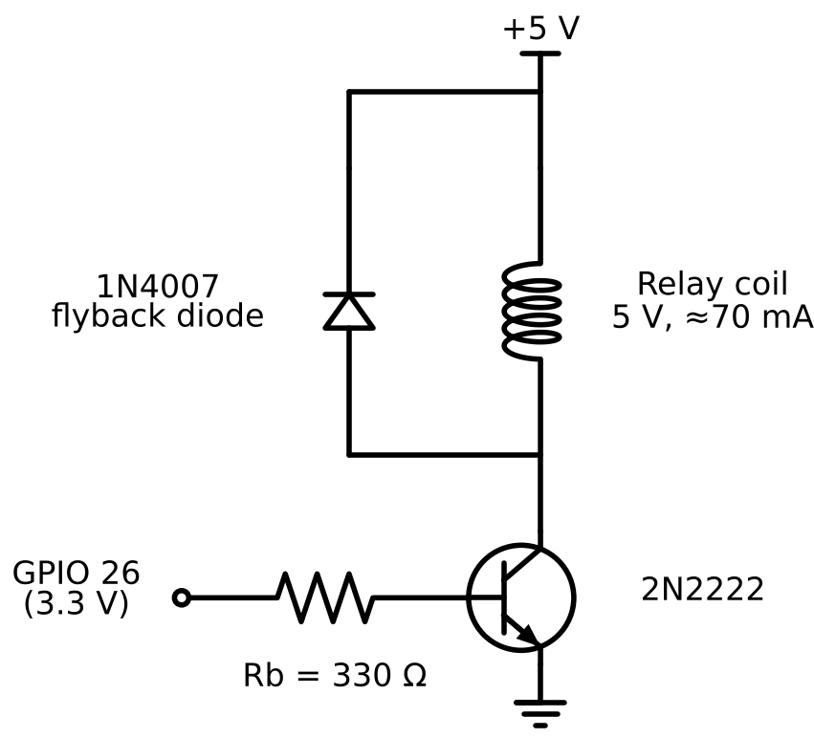
Figure 4.1: GPIO → base resistor → NPN transistor → relay coil, protected by a flyback diode.
Common Mistakes
- No base resistor, or the emitter not connected to ground.
- Transistor pinout taken from memory instead of the datasheet.
- Flyback diode reversed — this creates a short circuit when the transistor turns on.
- No common ground between the microcontroller and the load supply.
Quick Check
- Why can't the GPIO pin power the fan directly? (Its current limit is tens of mA; the fan needs far more)
- With the coil unpowered, which contact is connected to COM? (NC)
- Which end of the flyback diode goes to +V? (The cathode — the striped end)

5. Digital Electronics
Why this matters: Every processor, memory chip, GPIO pin and AI accelerator is built from digital logic. Two-state signals make decisions reliable because small amounts of noise are ignored. Without this topic, learners face floating inputs, misread buttons and control logic they cannot reason about. In the capstone, the fan decision is a Boolean expression running on the microcontroller.

5.1 Binary and Logic Levels
Each bit is a 0 or 1; N bits give 2^N possible values. A logic input reads HIGH above one threshold and LOW below another — between them the result is undefined. On a 3.3 V ESP32, roughly above 2.5 V reads HIGH and below 0.8 V reads LOW (always confirm in the datasheet). Feeding 5 V into a 3.3 V-only pin can destroy it; a divider or level shifter solves this.
Bits | Values | Where You Meet It
1 | 2 | A GPIO pin (HIGH/LOW)
8 | 256 | One colour channel of an image pixel
10 | 1,024 | Arduino Uno R4 default ADC
12 | 4,096 | ESP32 ADC

5.2 Logic Gates and Truth Tables
AND outputs 1 only if all inputs are 1 (a vault needing two keys); OR outputs 1 if any input is 1 (a house with two doors); NOT inverts its input. A NAND gate alone can build any other gate. In CMOS chips such as the 74HC series, every unused input must be tied HIGH or LOW, and each chip needs power, ground and a 100 nF bypass capacitor.
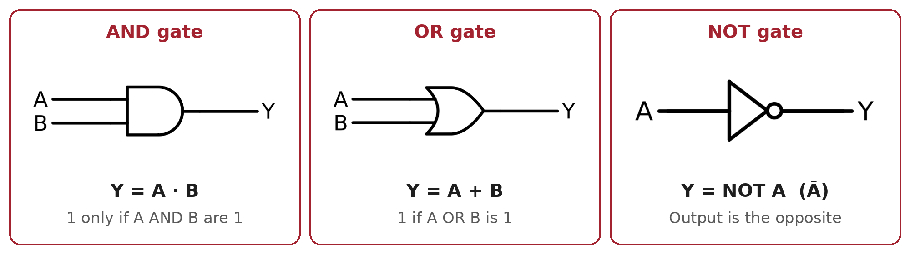

Figure 5.1: The three basic logic gates — AND, OR and NOT — with their inputs, output and Boolean expression.
A | B | A AND B | A OR B | NOT A
0 | 0 | 0 | 0 | 1
0 | 1 | 0 | 1 | 1
1 | 0 | 0 | 1 | 0
1 | 1 | 1 | 1 | 0

5.3 GPIO, Pull-ups and Decision Logic in Firmware
An unconnected input 'floats' and reads random values. A pull-up resistor (enabled internally with INPUT_PULLUP) holds the pin HIGH, and a button wired to ground pulls it LOW — so a pressed button reads LOW (active-low). Firmware logic mirrors gates: fan = hot && !manualOff. Hysteresis — switching on above 30 °C but off only below 28 °C — prevents the relay from chattering on and off near the threshold.
Common Mistakes
- Assuming a 3.3 V board is 5 V tolerant.
- Forgetting the chip's power pins, or leaving inputs floating.
- Forgetting the active-low inversion when using pull-ups.
- No hysteresis, causing relay chatter.
Quick Check
- How many values does an 8-bit number hold? (256)
- NOT(1 AND 0) = ? (1)
- With INPUT_PULLUP, what does an unpressed button read? (HIGH)

6. ADC & Sensors as Analog Devices
Why this matters: Sensors speak in volts; the analog-to-digital converter (ADC) turns volts into numbers that software and AI can use. Thermostats, wearables, phones, cars, industrial monitors, and every digital camera depend on it. Without understanding the ADC, readings can be wrong by several degrees without anyone noticing. In the capstone, this section completes the full sensing chain and produces the dataset used for pattern recognition.

6.1 How an ADC Works
An ADC compares the input voltage with a reference voltage (Vref) and reports a whole number: count = Vin / Vref × (2^N − 1). One step, the LSB, equals Vref / 2^N — about 0.81 mV for a 12-bit ESP32 at 3.3 V, and about 4.9 mV for a 10-bit Uno R4 at 5 V (the R4 can be set up to 14-bit). Signals must be sampled at least twice as fast as the fastest change of interest. The ESP32 ADC is non-linear near its ends, so analogReadMilliVolts() is used to get calibrated values. Think of it as a ruler: more marks (bits) give finer readings, and the ruler's length is Vref.
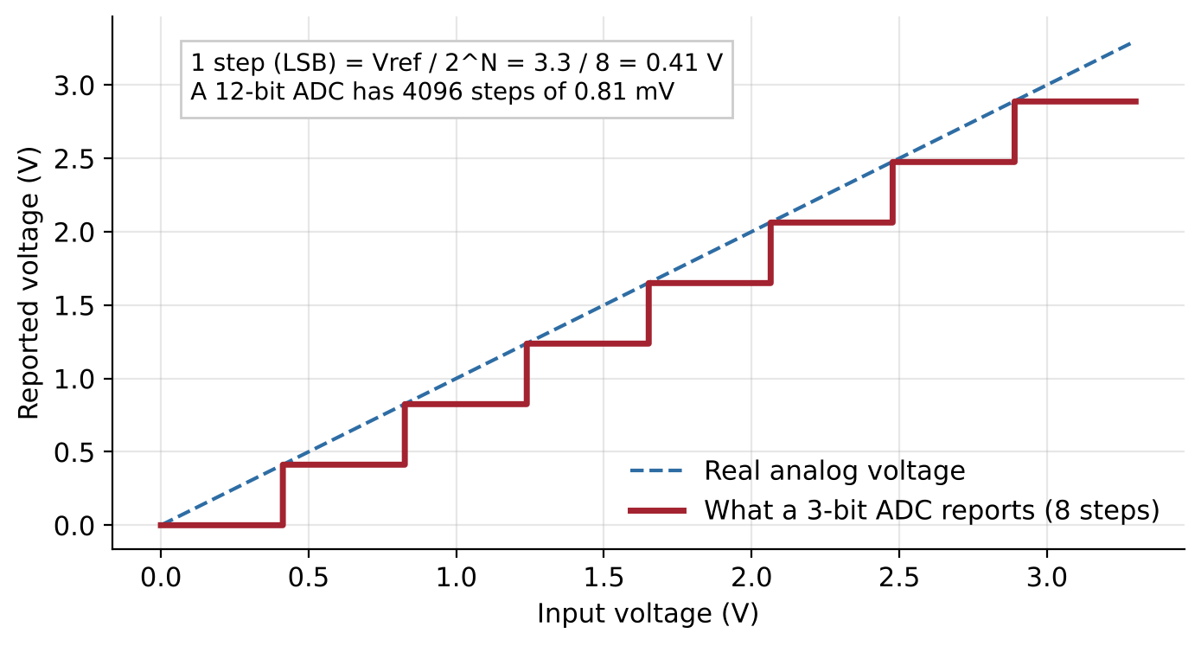
Figure 6.1: Quantisation — the ADC reports a staircase, not the smooth real voltage. More bits mean smaller steps.
Worked example: a 12-bit ADC with Vref = 3.3 V reads 2048. Vin = 2048 / 4095 × 3.3 ≈ 1.65 V.

6.2 Sensors as Voltage Dividers
Most simple sensors change their resistance. Placing the sensor as one half of a voltage divider turns that resistance change into a voltage the ADC can read. With the sensor as the bottom resistor, its resistance is recovered with Rsensor = Rfixed × Vout / (Vin − Vout). The fixed resistor should be close to the sensor's mid-range value to give the largest voltage swing.
Sensor | What Changes | Interface | Conversion
Potentiometer | Wiper position | Built-in divider | Volts → position
LDR (light) | Resistance falls as light rises | Divider with ≈10 kΩ | Resistance → relative light
NTC thermistor | Resistance falls as temperature rises | Divider with 10 kΩ | Beta equation → °C
Capacitive soil moisture | Output voltage falls when wet | Direct to ADC | Two-point calibration → %

For a 10 kΩ NTC thermistor (B ≈ 3950), temperature comes from the Beta equation: 1/T = 1/T0 + (1/B) × ln(R/R0), with T in kelvin and T0 = 298.15 K (25 °C).
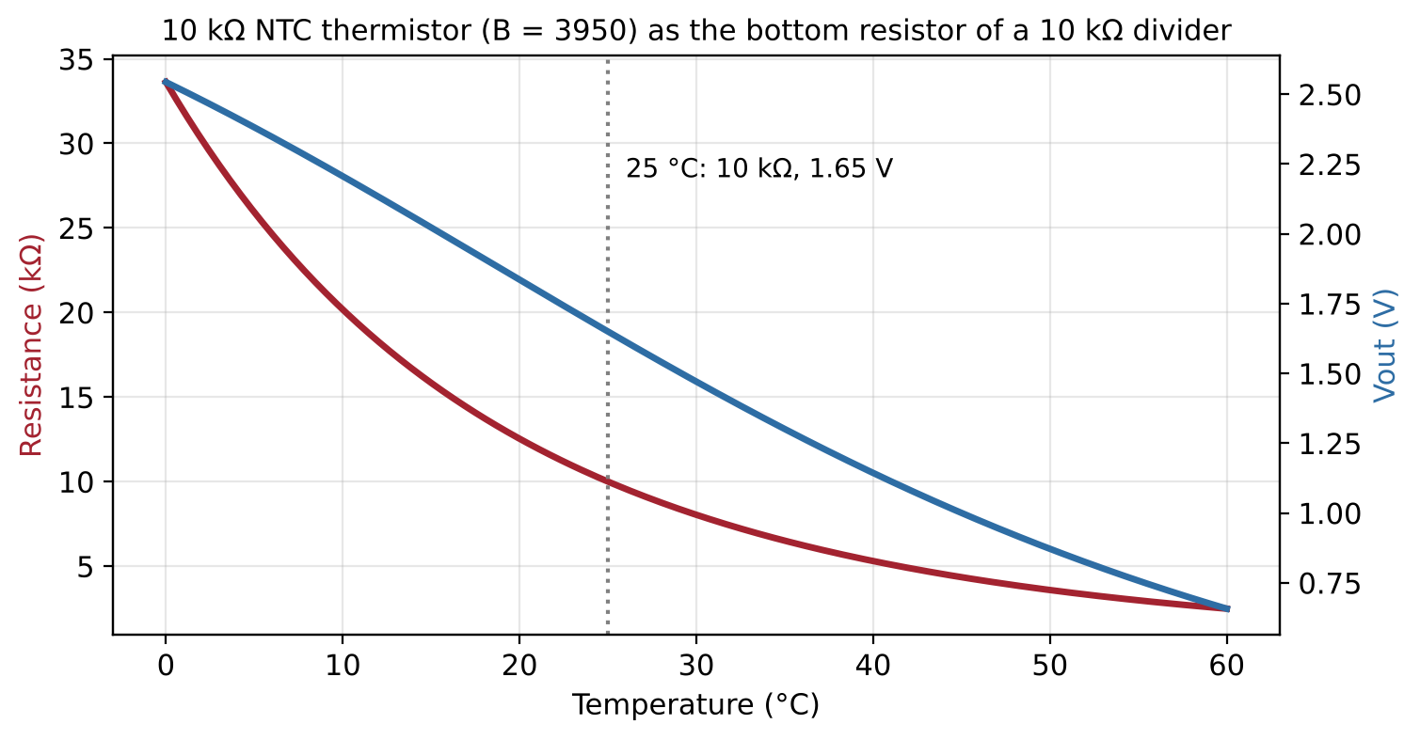
Figure 6.2: An NTC thermistor's resistance falls steeply with temperature; inside a divider, this becomes a smooth voltage the ADC can read.

6.3 Calibration, Averaging and Data Logging
Two-point calibration: measure two known references (for a soil sensor, dry air = 0% and a glass of water = 100%), fit a straight line y = m × x + c, and apply it to every reading. Averaging N samples cuts random noise by about √N. Always log a timestamp, the raw value, and the calibrated value to CSV, so mistakes can be corrected later — uncalibrated or unlabelled data trains bad AI models.

6.4 From ADC to Pixels: The Bridge to Computer Vision and Edge AI
A camera image sensor contains millions of photodiodes. Each one converts light to a voltage, and an ADC turns that voltage into a number — typically 10–12 bits in RAW form, and 8 bits per colour channel after processing. An image is simply a 2D grid of ADC readings. Thresholding a pixel and thresholding an LDR reading are exactly the same operation. Edge AI runs models directly on the device next to the sensor, so ADC quality, noise and calibration directly limit model accuracy. Your LDR is a one-pixel camera; a phone camera is about 12 million of them in a grid.
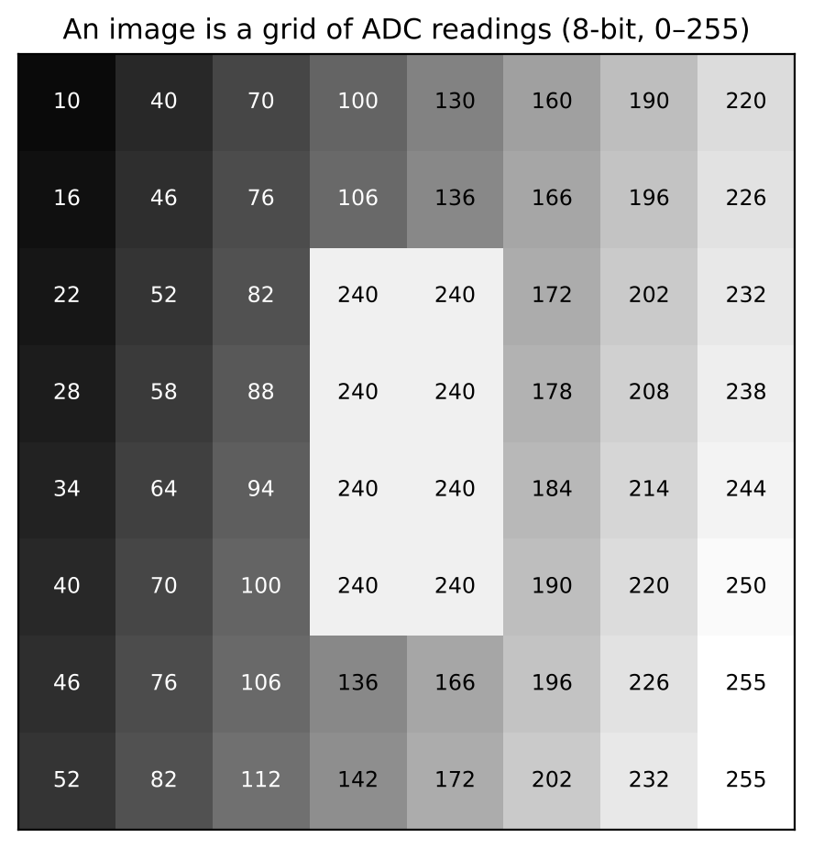
Figure 6.3: An 8 × 8 grayscale image shown as the ADC values (0–255) that make it up.
Common Mistakes
- Dividing by 1024 on a 12-bit board, or assuming Vref is exactly 5.00 V on USB power.
- Mixing up which resistor is on top of the divider.
- Using °C instead of kelvin in the Beta equation.
- Calibrating at only one point, or logging only calibrated values.
- Believing AI will fix bad sensor data — it learns the noise too.

Quick Check
- Which gives finer resolution: 10-bit at 5 V or 12-bit at 3.3 V? (12-bit at 3.3 V)
- If the LDR is the bottom resistor, does Vout rise or fall with more light? (Fall)
- Averaging 16 samples reduces random noise by about how much? (4×)
- An 8-bit pixel reads 200. Brighter or darker than mid-grey? (Brighter; mid-grey is about 128)

7. Debugging & System Integration
Why this matters: Engineers spend more time finding faults than wiring circuits, and hardware interviews often include a broken board. A structured method turns 'it doesn't work' into a located, explained fault. Without it, learners can only build circuits that work first time — which is almost none. In the capstone, this is where every subsystem is joined and tested.

7.1 A Structured Debugging Method
Like a doctor moving from symptoms to diagnosis, follow six steps and record each one in a debug log (symptom, hypothesis, measurement, cause, fix). Always check power and ground first, then measure along the signal path from source to load, halving the search area each time.
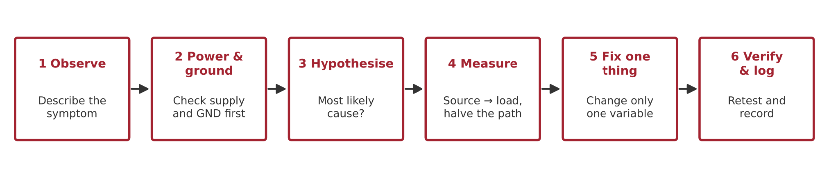
Figure 7.1: The six-step debugging method for locating any circuit fault.
Fault | Symptom | How to Find It
1. LED in backwards | LED never lights | Voltage across LED ≈ supply; check polarity
2. Missing common ground | Relay or sensor behaves randomly | Continuity test between grounds
3. 1 kΩ instead of 10 kΩ in a divider | Wrong sensor reading | Measure Vout; check colour bands
4. Flyback diode missing | Board resets when relay switches off | Inspect coil; check the schematic
5. Floating button input | Random presses | Check pinMode / pull-up resistor

7.2 Reading Datasheets to Make Decisions
Read a datasheet in this order: pinout, absolute maximum ratings (never exceed these), recommended operating conditions, electrical characteristics (typical vs minimum/maximum), and application circuits. Design to minimum/maximum values, not typical ones. Exercise: From the 2N2222 and IRLZ44N datasheets, find the maximum collector current, Vce(sat), and Rds(on) at Vgs = 4.5 V; from the ESP32 datasheet, find the maximum GPIO current and the ADC input range.
Quick Check
- What are the first two things to measure on a dead circuit? (Supply voltage and ground continuity)
- Is it safe to run a part at its absolute maximum rating? (No)

